Rahil sha

Informati0n technology :Pat

Grade 12b :2022

Table of content

Scenario and scope page 3 -4

User requirements page 5

Navigation/description of flow diagram page 6-7

Data structures page 8-10

Database design page 8

Class description and class diagram page 9

Text files and arrays page 10

Gui design page 11-16

Software design and tools (ipo) page 17-24

Data input/validation page 17-19

Data processing page 20-23

Data output page 24

SCENARIO / SCOPE : ONLINE EDUCATION

Scenario and scope define the task

My Topic: Community learning and self-testing program

Introduction

Online education over the years has evolved as a viable method for learning and helps assist struggling learners and achieving learners get that little more help that they need to perform their best.

Online learning is a type of education that's offered by schools and universities that are 100% online. It's a development that's happened in the 1990s due to the rise of the Internet. The online learning experience is typically synchronous but can also be asynchronous. Most schools and universities still use a learning management system to manage their online courses. Due to the advantages of online learning, it has become more prevalent compared to traditional classrooms. It also allows students to interact with different student populations while they're preparing for the job market.

What’s the Problem?

Studies have shown that some of the least effective ways of learning is by rewriting, highlighting and summarizing notes, yet these are the most common ways that students find themselves preparing for tests as they don’t know how to efficiently study and maximize time.

Time is of the essence. Students often find themselves struggling to cope with the work load as they grow older and their old inefficient ways of learning no longer suffices, some of these students may also not have the money or transport to go for tuitions so they are left a cut below the rest.

Solution

After doing research my solution to this is creating a program that helps enforce positive learning habits and keeps track of a learner’s notes. This will be a free program so that anyone can use it, this will allow students of a lower income background be able to be on par with students of an average income background. My program will also allow students to conduct self-tests and compare their results from previous tests and monitor their progress. They will also be able to search for notes from users in similar situations to them (i.e., same grade and doing same subjects) and gain an extra insight on the topics they are learning.

SCOPE

The program will be able to help users easily locate content, that will be useful to them by allowing them to filter content by grade, subject or search specific content using key words. Users will be able to create and generate content flashcards in an organized manner. Generated tests will be randomized helping leaners adapt to ever changing testing methods. Users will be able to view their overall performance in their subjects and edit their own personal details with ease.

User Requirements

Who are the users and what are their roles? ---------------------------------------------------------------------------------------------------------------------

* Students - high school students who will use the app to study, self-test, monitor progress and search for others study notes.

---------------------------------------------------------------------------------------------------------------

* Admins– People who will monitor accounts and enforce user agreement policy.

----------------------------------------------------------------------------------------------------------------

|  |  |  |
| --- | --- | --- |
| User : | Activities : | Limitations : |
| Students | Users can create accounts and will be allowed to make, edit and delete their own study notes and generate self-tests on those study notes. They will be able to view their test averages from previous self-tests and make a comparison to their recent marks. Users will be able to search the database for study notes from other users, access them and generate tests on those notes. | Users will not be able to make changes to any information that is not their own (i.e., if they’re studying from the study notes of another user and the study notes has an error, they will not be able to make changes to it) |
| ADMINs | Will have access to all users information and their study notes, will be able to delete sets of study notes deemed inappropriate or users accounts who violate the user agreement policy. Will be able to read feed back and view reports. They will also be able to view information about the system as a whole | Moderators serve an administrative purpose only and will not be able to create an account or do any activity that normal users can do. |

Navigation/ description of flow diagram

Full overall flow:

frmLogin

frmAdmin

frmSignUp

frmWelcome

frmStudy

frmSearch

frmTest

admin flow:

frmLogin

frmAdmin

USER(STUDENT) FLOW:

\

frmLogin

frmSignUp

frmWelcome

frmSearch

frmStudy

frmTest

Data structures:

Database design:

tblUser

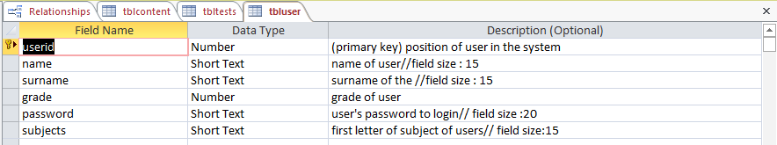

tblTests

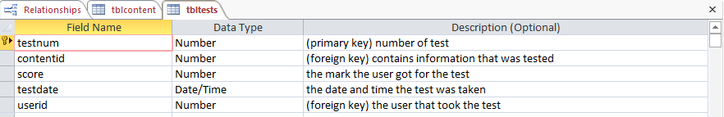

tblcontent

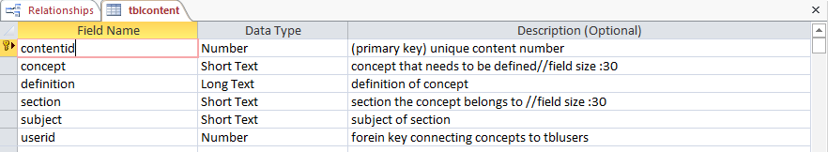

Relationships:

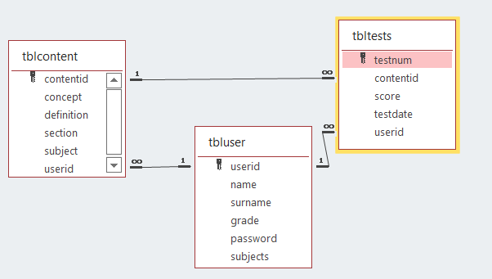

Class and description diagram:

|  |
| --- |
| Login Object |
| -fpassword (String)  -fName(string)  -fSurname(string) |
| +Constructor (sName,fSurname,sPassword)  +GetPass :string;  +GetSurname :string  +GetName :string  +tostring :string  +DetermineValidity (sUsername,sPassword):Boolean  +GenerateSubjects |

Text files and arrays :

Text files :

My program will use text files in multiple areas to help give and gain information to and from users. Examples of these areas are:

* On every page there will be a help button that displays help information specific to that page stored in a text file.
* On the welcome page there will be an area that if the user has come across any problems with the program. They can send their feedback and this information will be saved on a text file to view for later.
* Users will be able to flag content they deem as inappropriate and it will be saved to a text file
* A text file will also be used to generate tests.

Arrays:

I will be multiple arrays in my project :

FRMLogin:

* On the login page there will be a section array that filters out repeat sections before populating the users section combo box.

FRMWELCOME:

* There will be 4 arrays that will be used to generate a bar graph. arrsubjectnames to store the subjects the user does. arrSubjectsum to store the sum of all the user’s test scores. arrSubjectcount counts the number of tests taken for that specific subject and arrSubjectaverage that determines a user’s overall average for a subject.

FRMTest:

* An array will be used for the multiple-choice answers to filter out repeats

(Example: what animal barks? A. Dog B. Cat C. Dog D. Mouse)

**GUi Design (please note that gui is subject to change)**

**FrmADMIN**

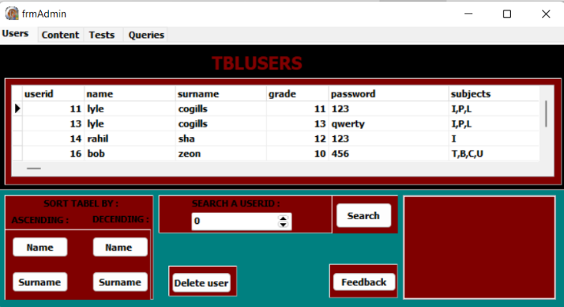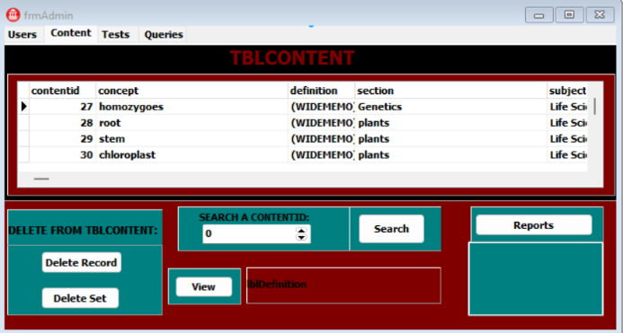

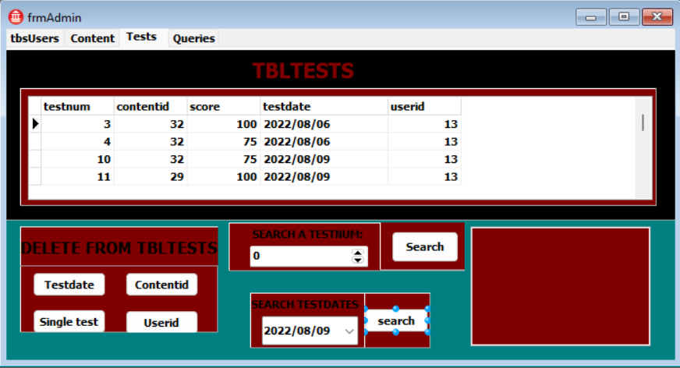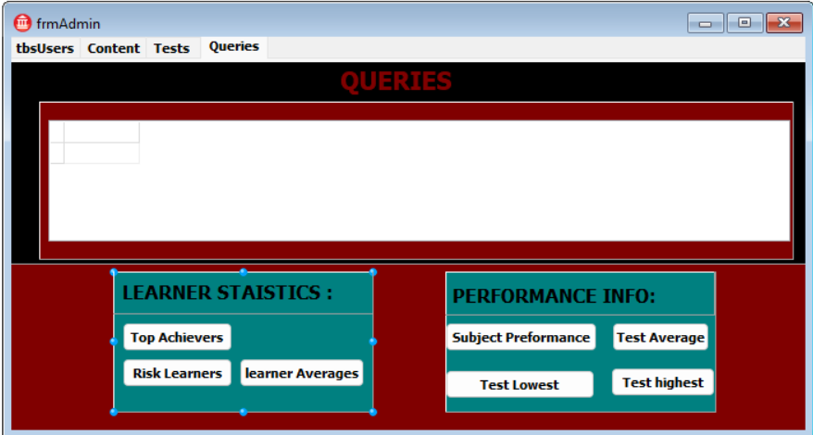

|  |  |
| --- | --- |
| Component | function |
| btnNameSortD | Sorts names in data base in descending order |
| btnNameSortA | Sorts names in data base in ascending order |
| btnSurnameSortD | Sorts Surnames in data base in descending order |
| btnSurnameSortA | Sorts Surnames in data base in ascending order |
| btnFeedback | Reads from feed back text file |
| btnDeleteUser | Deletes selected user from tblUser and associated tables linked to that user |
| spnStudent | Allows user to enter a userid to search for |
| redOutPutFeedBack | Displays feeb back text file |
| dgbUsers | Displays user tabel |
| spnContentid | Allows users to enter a contentid to search for |
| btnContentidSearch | Locates a contenti d in tblcontents |
| memdisplay | Displays reports |
| btnReports | Reads from the repots text file |
| btnView | Reads the definition of a selected record |
| lblDefinition | Displays definition of a selected record |
| btnDeleteRecord | Deletes a single record |
| btnDeleteRecordSet | Deletes a record and asscociated records in its sectionn |
| dgbContent | Displays tblcontent |
| spnTestSearch | Allows user to enter a testnum to search for |
| btnTestSearch | Locates test num entered by user |
| btnDeleteTestDate | Deletes all tests of a specific date |
| btnDeleteTestContentid | Deletes all tests of a specific content id |
| btnDeleteTest | Deletes selected test |
| btnDeleteTestUser | Deletes all tests of a specific user |
| dgbTests | Displays tbltests |
| btnTopAcheivers | used to show learners with averages above 80 |
| btnRiskLearners | used to show learners with averages below 40 |
| btnLearner averages | used to show learners averages |
| btnSubjectPreformances | Used to show average for each subject |
| dtpTestDate | Allows user to enter a testdate to seach |
| btnSearchesTestDate | Displays all tests matching selected testdate |

Where admins can search, monitor and delete users or concepts from tblusers and tblconcepts respectively as they deem fit, A admin can also look up a user’s academic information

**Frmsearch**

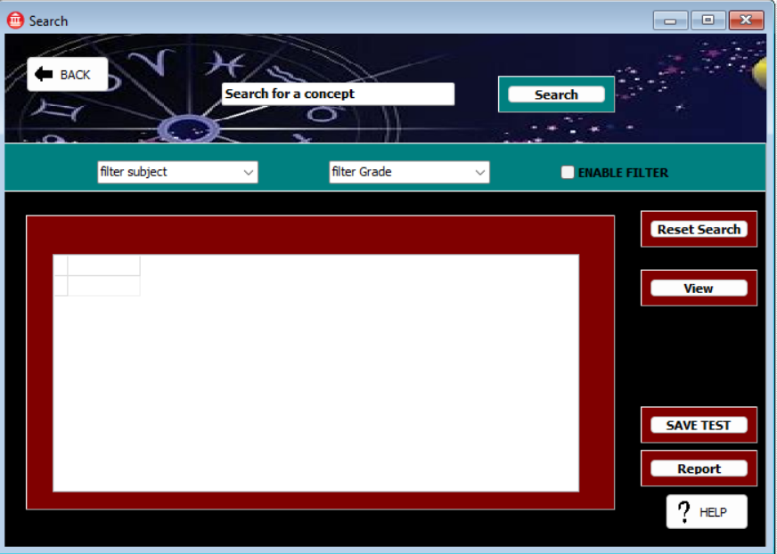

|  |  |
| --- | --- |
| Component | function |
| btnback | Moves user from search page to welcome page |
| edtConcept | Contains the information on What concept the user wants to search |
| btnSearch | Searches for the content from edtconcept in the database |
| cmbGrade | Allows user to choose what specific grade they are searching the concept for |
| cmbSubject | Allows user to choose what specific subject they are searching the concept for |
| chkEnableFilter | Allows user to enable and disable the subject and grade filters |
| btnSave | Btnsave saves selected concept to users study set |
| BtnReport | Allows users to report a concept they deem as inappropriate and saves it to a textfile |
| btbHelp | Provides information to help guide newcomers to the application |
| btnView | Allows user to view definition of a concept they enter the content id for |
| btnResetSearch | Resets dbGrid to state it was when the user entered the search page. |
| dbgConcepts | Data base gird that displays the contents in the tblconcepts table |

Page which users are able to search for topics and filter them to narrow results. They will also be able to save study notes they like and test themselves on it. Users will be able to report notes they deem inappropriate or as misinformation

**frmstudy**

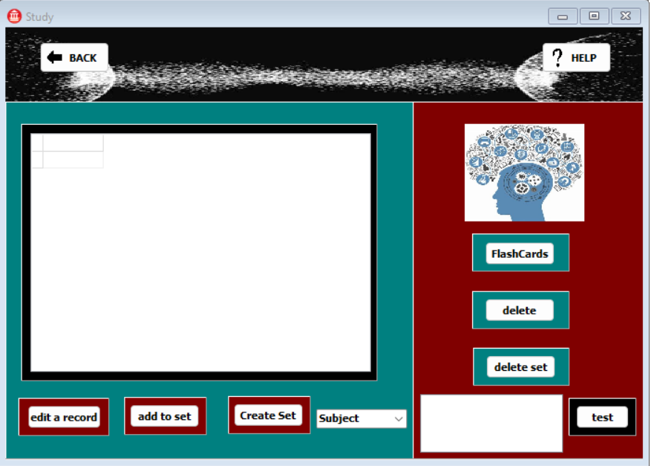

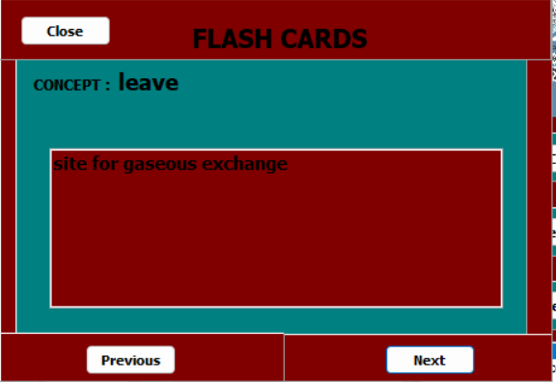

|  |  |
| --- | --- |
| Component | function |
| btnBack | Moves user back to elcome screen |
| btnTest | Moves user to frmtest |
| lstSection | Allows user to select what section they want to be tested on |
| btnDeleteSet | Deletes an entire set from user’s study notes (e.g. all records linked to the section hardware) |
| btnDelete | Deletes a single record from tblconcepts |
| btnFlashCards | Displays a hidden panel that allows users to go through their notes in a suitable manner without it being logged as a test |
| btnEdit | Edits an existing record in tblconcepts |
| btnAddToSet | Adds another concept to an selected set |
| btnCreateSet | Creates a new set and adds to tblconcepts |
| dbgConcept | Data base grid that displays the contents of tblcontent |
| btbHelp | Provides information to help guide newcomers to the application |
| btnPrevious | Moves back a record in the study set |
| btnNext | Moves forward a record in the study set |
| btnClose | Hides flash card panel |
| cmbSubjects | Contains subjects of the user they have to select one before being able to create a new study set |

Page on which a user cand create edit and delete study notes they can also test themselves on study notes that they have created or saved through the test function in the program or go through notes through the flashacards function.

**Frmtest**

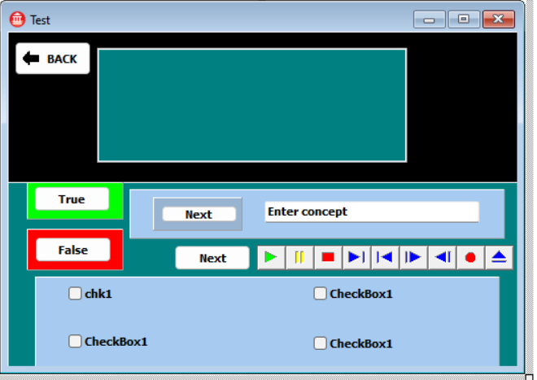

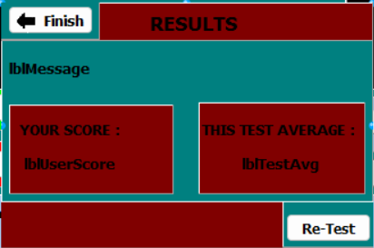

|  |  |
| --- | --- |
| Component | function |
| btnTrue | Allows user to indicate if they think the answer is true |
| btnFalse | Allows user to indicate if they think the answer is false |
| edtAnswer | Allows user to enter what they think is the corresponding definition |
| btnNext | Allows user to indicate when they are ready for the next question |
| chkA | Allows user to indicate if they think the answer is Option A |
| chkB | Allows user to indicate if they think the answer is Option B |
| chkC | Allows user to indicate if they think the answer is Option C |
| chkD | Allows user to indicate if they think the answer is Option D |
| redOutput | Outputs from database question they have to answer |
| mpCorrectAns | Plays an audible sound to indicate the user answered correctly |
| btnRetest | Resets the test program without having to go back to the study page |
| lblUserscore | Displays the percentage the user got on this test. |
| lblTestAvg | Displays the overall average for this test |

Screen which users are taken when they press the test option on frmstudy the program will randomly generate questions of three varieties true and false, multiple choice, or typing out the corresponding definition/concept. During one questioning phase the components for the other questioning phase will be hidden (example during the true and false questions the multiple-choice components will be hidden)

**SOFTWARE DESIGN TOOLS (IPO)**

DATA INPUT

INPUT INTERFACES ( minimum 2)

frmSignup

|  |  |  |  |  |  |  |  |
| --- | --- | --- | --- | --- | --- | --- | --- |
| INPUT | VARIABLE | DATATYPE | FORMAT | SOURCE | COMPONENT | VALIDATION | ERROR |
| First name | sName | string | Letters  (a-z) | keyboard | editbox | Checks if the field is blank or the name has any numbers or foreign strings  (i.e., ; , @) | Please check you have entered correct name and surname or please check you have all information filled in |
| Surname | sSurname | string | Letters  (a-z) | keyboard | editbox | Checks if the field is blank or the surname has any numbers or foreign strings  (i.e., ; , @) | Please check you have entered correct name and surname or please check you have all information filled in. |
| Grade | iGrade | integer | Numbers | Mouse | comboBox | Checks to see if any item in the combox box has been selected | Please check you have all information filled in. |
| Subjects | sSubject | string | Letters  (a-z) | Mouse | checkbox | Checks to see if at least one subject has been selected | Please check you have all information filled in. |

frmstudy

|  |  |  |  |  |  |  |  |
| --- | --- | --- | --- | --- | --- | --- | --- |
| INPUt | VARIABLE | DATATYPE | FORMAT | SOURCE | COMPONENT | VALIDATION | ERROR |
| Concept | sConcept | string | alphanumeric | keyboard | inputbox | Checks to see if the field is not blank or if the user has more than one definition like this (if its repeated) | You cannot repeat sections or enter blank fields. |
| definition | sDefinition | string | alphanumeric | keyboard | inputbox | Checks to see if the field is not blank or if the user has more than one definition like this (if its repeated) | You cannot repeat sections or enter blank fields |
| Section | sSection | string | alphanumeric | Keyboard | inputbox | Checks to see if the field is not blank | Invalid section |
| subject | sSubject | string | Letters  (a-z) | Mouse | combobox | Checks if the user actually does that subject or not subject selected | Please verify subjects/you don’t do that subject |
| contentid | iContentid | integer | numeric | keyboard | inputbox | Checks if it is a real number. checks if the content id is a real one. Checks if the contented belongs to that specific user | please enter a valid contentid.  contenid you searched does not exist.  The contentid you tried to delete does not belong to you |

frmAdmin

|  |  |  |  |  |  |  |  |
| --- | --- | --- | --- | --- | --- | --- | --- |
| INPUt | VARIABLE | DATATYPE | FORMAT | SOURCE | COMPONENT | VALIDATION | ERROR |
| Contentid | iContentid | integer | numeric | keyboard | spinedit | Checks to see if the contentid actually has a record | The contentid you searched does not exist. |
| Userid | iUserid | integer | numeric | keyboard | spinedit | Checks to see if the userid actually has a record. | The userid you searched does not exist. |
| tesnum | iTestNum | integer | numeric | keyboard | spinedit | Checks to see if the testnum actually has a record. | The testnum you searched does not exist. |
| testdate | dDate | sTdateTime | Date(yyyy-mm-dd) | Mouse | Date time picker | Checks to see if the date within a certain range (ex 1900-2022). Checks if the test date they searched has any actual tests on that day | Invalid date range. the test date you searched has no tests |

frmLogin

|  |  |  |  |  |  |  |  |
| --- | --- | --- | --- | --- | --- | --- | --- |
| INPUt | VARIABLE | DATATYPE | FORMAT | SOURCE | COMPONENT | VALIDATION | ERROR |
| Username | sUsername | string | Letters  (a-z) | keyboard | editbox | Checks if blank. Checks if username together with password matches that in database. | Please full in all fields. Wrong username or password |
| Password | sPassword | string | Letters  (a-z) | keyboard | editbox | Checks if blank.  Checks if username together with password matches that in database. | Please full in all fields. Wrong username or password |

Input Validation (4 different types)

Name and password (string)

Login:

When logging in, the user has to enter their name and password. The program searches through the database for the name and password entered in. If the name AND password is not found, the user is notified that the account they are looking for does not exist. If the username entered is found but the password entered is not or vice versa the user is notified they entered the wrong details

Associated error message(s): ''The name or password is incorrect''

Search results (Boolean)

When the user is searching for a contentid /testnum/ userid if what they search for is not contained in the database it will display an error message and if it is found it will present what matched their search in the database.

Associated error message(s): ''The contentid/ testnum/ userid you searched for does not exist''

content id(integer)

When a user locates a content id to add, delete or update a study set the program checks if the content id entered is a real number and doesn’t contain any letters of foreign characters.

Associated error message(s): '' please enter a valid content id ''

Test dates(date and time)

When a test is done the date and time that the test is taken is captured, if another test is taken after that and the time has been altered on the computer, if the date and time of the second test is before the date and time of the first test and error message will show. When searching test dates checks that the search is within a reasonable range.

Associated error message(s): ''please check your date time settings test discarded' / “Invalid date range”

Validate for null/empty field

On the signup page the program will check if all the criteria required is filled in by checking if the information in the edit boxes is not equal to blank space. If it is equal to a blank space depending on the field that’s not filled in you will receive an error message.

example: “Please check that you have all information filled in”.

Also, on the search page and study page you will have to search for a content id.If the field is blank it will display an error me

Error message - “please enter a valid contentid”.

All error messages will be displayed by a show message.

Test if value was elected in selection component:

1. Check if the user checked subject check boxes on signup page
2. Check if the user selected a subject when creating a content set from the subject combo box
3. Checking if the user selected a grade from the grade list box on the signup page

Associated error message(s): ''Please check you have all fields filled in”

''Please chose a subject from the combo box to create a set for”

What processing needs to be done? (8 types)

* Calculating average mark for each subject
* Generating a bar graph
* Deleting user accounts
* Validating name and password for login
* Creating user’s study notes
* editing study notes
* Searching for information in the database
* Generating tests

How will the processing be done? (4 types)

1.Validating names and passwords

In order to validate usernames and passwords the program has to:

* Extract username and password from edit boxes:

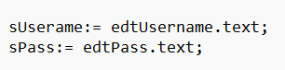

* Search through database
* Generate username
* Compare the corresponding database username and password to the one entered in:

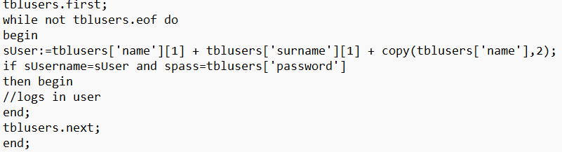

2.Calculating average mark of subject

To calculate average mark the program has to:

* Extract all of the marks from previous tests of a subject
* Count the number of tests that marks were extracted

Add the marks extracted and divide it by the number of tests:

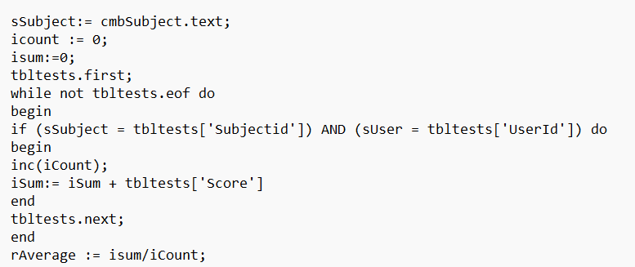

3.Users creating study notes

To create study notes program has to:

* Get the section the study notes are based on from user
* Get the subject the study notes are on from the user:

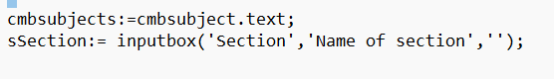

* Extract concept and corresponding definition:



* Add to tblconcepts :

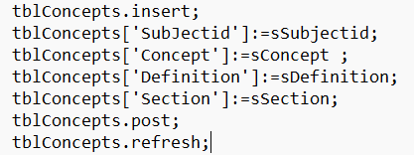

4.Deleting user accounts

To delete a user’s account:

* Locate the user they want to delete:



* Delete the user in tbluser:

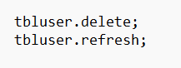

* Delete associated records of the user (example their study notes from tblcontents):

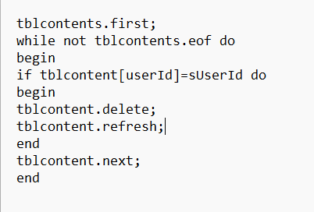

DATA OUTPUT (minimum 2)

frmTest

|  |  |  |  |  |
| --- | --- | --- | --- | --- |
| Output | Variable | Format | Source of output | Display  Component |
| concept | sConcept | String | database | RichEdit |
| Definition | sDefinition | String | database | RichEdit |
| user Percentage | rPercentage | Real (formatted to 2 decimals) | database | label |
| Average test score | rAverage | Real (formatted to 2 decimals) | database | label |
| Multiple choice answers | ArrMultiChoiceAns | String | database | checkbox |

frmWelcome

|  |  |  |  |  |
| --- | --- | --- | --- | --- |
| Output | Variable | Format | Source of output | Display  Component |
| Subject | arrSubjectnames | String | database | bargraph |
| Average | arrSubjectAverage | Real (formatted to 2 decimals) | Database | Bar graph |
| name | sname | String | Database | label |
| surname | ssurname | String | Database | label |
| password | sPassword | String | database | label |
| Help dialogue | sline | string | textfile | showmessage |

frmAdmin

|  |  |  |  |  |
| --- | --- | --- | --- | --- |
| Output | Variable | Format | Source of output | Display  Component |
| Test date | dDate | Tdatetime (YYYY/MM/DD) | database | richedit |
| feedback | sline | String | Text file | Rich edit |
| reports | sline | String | textfile | memo |